**Stereochemistry**

**Q.1 what is Absolute configuration?**

**Ans.** An absolute configuration refers to the spatial arrangement of the [atoms](https://en.wikipedia.org/wiki/Atom) of a [chiral](https://en.wikipedia.org/wiki/Chirality_(chemistry))[molecular entity](https://en.wikipedia.org/wiki/Molecular_entity) (or group) and its [stereochemical](https://en.wikipedia.org/wiki/Stereochemical) description e.g. R or S,referring to Rectus, or Sinister, respectively.Absolute configurations for a chiral molecule are most often obtained by [X-ray crystallography](https://en.wikipedia.org/wiki/X-ray_crystallography).

**Q.2 What are the basis of R and S configuration?**

**Ans.** When the absolute configuration is obtained the assignment of *R* or *S* is based on the [Cahn–Ingold–Prelog priority rules](https://en.wikipedia.org/wiki/Cahn%E2%80%93Ingold%E2%80%93Prelog_priority_rules).

Absolute configurations are also relevant to characterization of [crystals](https://en.wikipedia.org/wiki/Crystal).This approach labels each chiral center *R* or *S* according to a system by which its substituents are each assigned a *priority*, according to the [Cahn–Ingold–Prelog priority rules](https://en.wikipedia.org/wiki/Cahn%E2%80%93Ingold%E2%80%93Prelog_priority_rules) (CIP), based on atomic number.

**Q.3 What is R and S configuration?**

**Ans.** If the center is oriented so that the lowest-priority of the four is pointed away from a viewer, the viewer will then see two possibilities:

1. If the priority of the remaining three substituents decreases in clockwise direction, it is labeled*R* (for [*Rectus*](https://en.wiktionary.org/wiki/rectus), Latin for right),
2. if it decreases in counterclockwise direction, it is *S* (for [*Sinister*](https://en.wiktionary.org/wiki/sinister), Latin for left).

**Q.4 What is Conformational analysis?**

**Ans.** The infinite number of momentary arrangements of the atoms in space which result through rotation about a single bond are called conformations or rotational isomerism.

**Q.5 What are the conformations of butane?**

**Ans.** Butane has three conformers relating to its two methyl (CH3) groups:

1. two *gauche* conformers, which have the methyls ±60° apart and are [enantiomeric](https://en.wikipedia.org/wiki/Enantiomer).
2. *anti*-conformer, where the four carbon centres are coplanar and the substituents are 180° apart (refer to free energy diagram of butane).

**Q.6 What is the energy difference between Energy of Butane conformation?**

**Ans.** Energy difference between gauche and anti is 0.9 kcal/mol associated with the [strain](https://en.wikipedia.org/wiki/Strain_(chemistry)) energy of the gauche conformer. The anti conformer is, therefore, the most stable (≈ 0 kcal/mol). The three eclipsed conformations with dihedral angles of 0°, 120°, and 240° are not considered to be conformers, but are instead transition states between two conformers.[]](https://en.wikipedia.org/wiki/Conformational_isomerism#cite_note-dougherty-7) Note that the two eclipsed conformations have different energies: at 0° the two methyl groups are eclipsed, resulting in higher energy (≈ 5 kcal/mol) than at 120°, where the methyl groups are eclipsed with hydrogens (≈ 3.5 kcal/mol).

**Q.7 What are the Conformations of Ethane?**

**Ans**. Two carbon atoms are connected by single covalent bonds and 6 hydrogen are attached to the two carbon atoms.If one methyl group is fixed and second one is rotated about the C-C singke bond, large number of arrangements of hydrogen atoms are possible on one carbon atom with respect to other carbon in the space are obtained.these represents the conformations.

1. Staggered
2. Eclipsed
3. Gauche

**Q.8 Name the methods to represent Conformations of ethane.**

**Ans.** Methods to represent conformations

1. Sawhorse formula-This is the simple method for representing three dimensional formulae.the molecule is viewd from above and from the right and are projected on the paper.
2. Newman projection formula-It is highly used method.Theseare obtained by viewing the moleculealong the bond joining the two carbon atoms.The carbon atoms near the eye is represented by a point. And three atoms or groups attachedto it by three equally spaced(120) radii.the carbon atoms, which is farther away from eye is shown by circle three atoms or groups attached to it by three equally spaced.

**Q.9 How to represent Sawhorse projection?**

**Ans.**

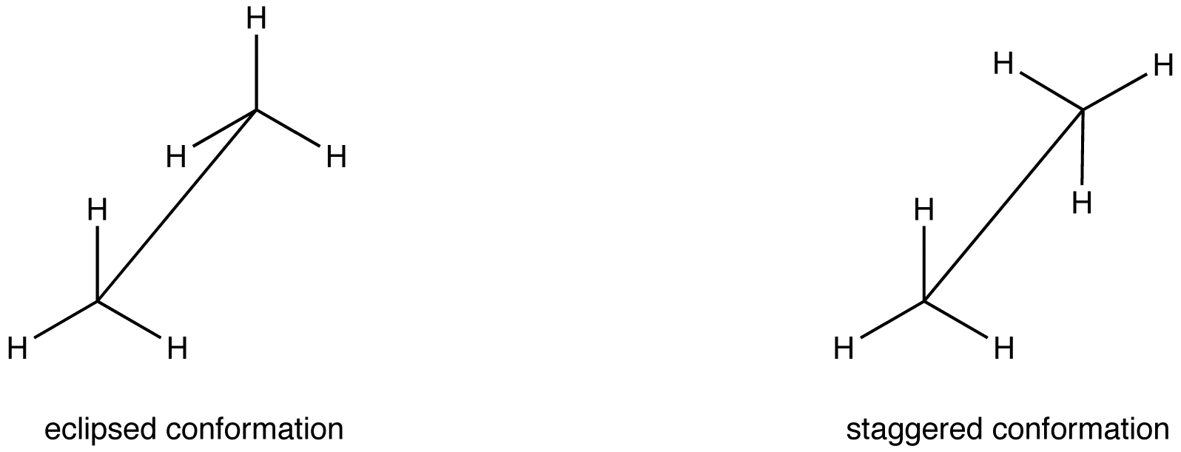

Sawhorse projection

**Q.10 Draw all the possible geometrical isomers for the complex [Cr(en)2(CN)2]+**

**Ans**.

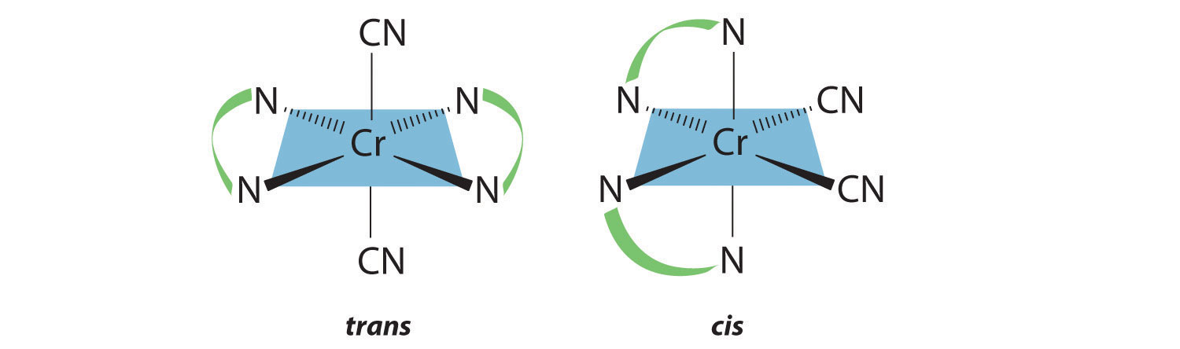

**Q.11 What is the necessary and sufficient condition for a molecule to be optically active?**

**Ans:** The molecule should be chiral or the molecule and its mirror image should be non-superimposable.

**Q.12 Does the presence of one chiral carbon atom make the molecule optically active ?Explain.**

**Ans.** Yes the presence of one chiral carbon atom make the molecule optically active and hence show optical activity.

**Q.13 How many optical isomers can exist for 2,3 butandiol? Would all of these be optically active?**

**Ans-**There are three optical isomers, on of which is inactive (the meso form? Because of the two carbon atoms have same groups arranged in opposite configuration.

